WPCode Plugin Research

# Ready-made Snippets Library

The WPCode plugin has a ready-made Snippets Library containing various plugins for different functionalities as:

1. Allow SVG Files Upload: Enables uploading SVG (Scalable Vector Graphics) files to your WordPress media library. This is useful for logos, icons, and other graphics that can be resized without losing quality.
2. Completely Disable Comments: Disables comments for all post types, both in the admin panel and on the frontend of your website. This can be helpful if you don't want to deal with spam or moderation.
3. Disable Attachment Pages: Hides the individual pages for uploaded attachments like images or videos from public view. This helps keep your site cleaner and prevents unnecessary links.
4. Disable Automatic Updates: Completely disables automatic updates for WordPress core, themes, and plugins. This requires manual updates and carries security risks, so use with caution.
5. Disable Automatic Updates Emails: Prevents WordPress from sending email notifications about available updates. Useful if you manage updates manually or find the emails distracting.
6. Disable Gutenberg Editor (use Classic Editor): Switches the default editing experience back to the classic TinyMCE editor instead of the newer block-based Gutenberg editor. Useful for users who prefer the old editor workflow.
7. Disable The WP Admin Bar: Hides the admin bar (a toolbar at the top of the screen) from all users on the frontend, making your website cleaner and removing a potential access point for unauthorized users.
8. Disable Widget Blocks (use Classic Widgets): Replaces the block-based widget interface with the classic list-based widget management, allowing users familiar with the old system to continue using it.
9. Disable WordPress REST API: Disables the WordPress REST API, which allows external applications to access your website data. This improves security by closing a potential vulnerability, but may break integrations with other tools.
10. Disable XML-RPC: Disables XML-RPC, a protocol used for some functions like trackbacks and pingbacks. Useful to improve security as it can be exploited by some malware.
11. Duplicate Post/Page Link: Adds a "Duplicate" link next to posts, pages, or any custom post type, allowing you to create a copy with one click. Useful for quickly creating similar content with minor adjustments.
12. Remove WordPress Version Number: Hides the WordPress version number from your website's frontend and RSS feeds. This can improve security by making it harder for attackers to target specific vulnerabilities in your version.

# Custom Code Snippets:

The WPCode plugin allows to add custom code in our site. This includes adding following types of code snippets as:

1. HTML
2. Text
3. JavaScript
4. PHP
5. Universal
6. CSS

HTML Snippets: These snippets are handy when you need to swiftly integrate scripts into your website by copying and pasting code from providers. For instance, you can easily incorporate tracking scripts like Google Analytics or Facebook Pixel. They are also useful for adding advertisements or any other HTML code swiftly. Additionally, you can employ HTML snippets for creating more intricate layouts such as banners or ads, although for simpler text-based content, the text snippet might be more suitable.

Text Snippets: Text snippets offer a different editing experience compared to other types. If you're accustomed to using the default WordPress editor, you'll find text snippets familiar. These snippets aren't solely focused on code; instead, they allow easy insertion of images, media files, and integration of shortcodes from other plugins to extend functionality effortlessly.

JavaScript Snippets: When you need to insert and execute JavaScript code directly, JavaScript snippets are the way to go. Unlike HTML, you don't have to wrap the code in <script> tags as it automatically gets wrapped when executed, simplifying the process.

PHP Snippets: PHP snippets provide immense power as they enable the execution of nearly any type of PHP code. This allows for the addition of new features or the modification of existing functionality using WordPress hooks and other techniques. They're particularly handy for adding specific functionality to your site, which is why most of the snippets generated by WPCode's in-plugin generator are PHP snippets.

Universal Snippets: These snippets combine the functionality of PHP snippets with the flexibility of HTML. They allow you to execute PHP code while integrating it seamlessly with HTML, mimicking the structure of a .php file. This versatility makes them ideal for creating template-like layouts or custom shortcodes that include PHP code.

CSS Snippets: Introduced in version 2.0.4, CSS snippets provide a straightforward way to add custom styles to your website. The editor is optimized for CSS coding, offering instant syntax verification and autocomplete features to streamline the process. This ensures that you can easily write correct CSS code and take advantage of WPCode's powerful features for managing where those styles are applied on your site.

# Smart Conditional Logic:

## No Coding Required:

WPCode allows users to create complex rules for loading code snippets and scripts without needing coding skills.

Its interface is user-friendly yet powerful, making snippet management easy.

Optimizes site performance by controlling where snippets are loaded, preventing unnecessary script loading.

## Target Specific Pages Easily:

Smart Conditional Logic rules enable users to combine multiple criteria to target specific pages.

Criteria cover various page types such as archives, categories, single posts, and the homepage.

Users can also specify exclusions, indicating pages where snippets should not be loaded.

## Simplified eCommerce Tracking:

WPCode provides ready-made rules for tracking conversions on eCommerce platforms like WooCommerce and Easy Digital Downloads.

This feature streamlines the process of setting up tracking for essential pages within the sales funnel.

## Rule Reusability and Performance Improvement:

Users can save snippets to the cloud for reuse across multiple sites, facilitating rule reuse.

Selective loading of snippets improves overall site performance, especially for marketing and tracking scripts, which might otherwise slow down the site.

# Advanced Auto-Insert Locations:

The Advanced Auto-Insert Locations feature in WordPress is a tool that automatically places code or content in different parts of a website without requiring manual editing for each page or post.

This feature allows users to select specific locations where they want the code to appear. For instance, they can choose to display it before the main content of every post or only in the header section of the site. By selecting the desired option, the code will be inserted into the chosen location automatically.

It streamlines the process of adding code or content to various parts of a website, eliminating the need for manual insertion on each page or post.

1. To add a snippet to specific location,
2. You have to scroll in for Insertion Section on the site.

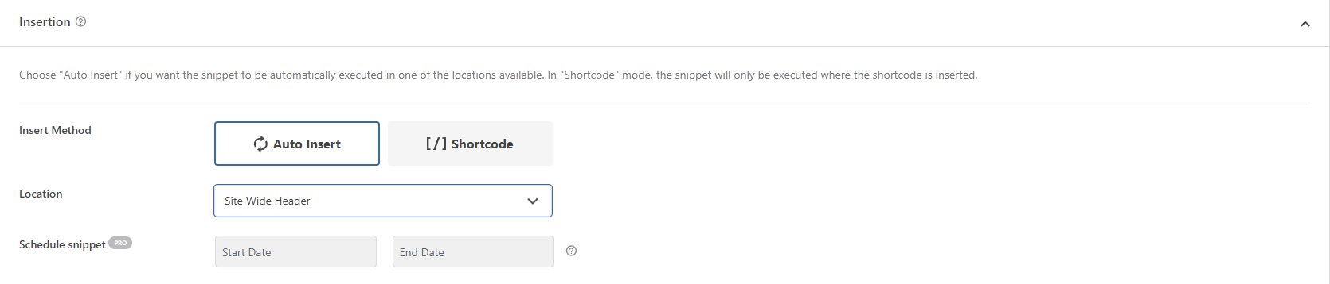

1. Now, choose the locations where you want to add the specific snippet.
2. Locations can be Global, Page Specific and there is one more additional feature for eCommerce also.

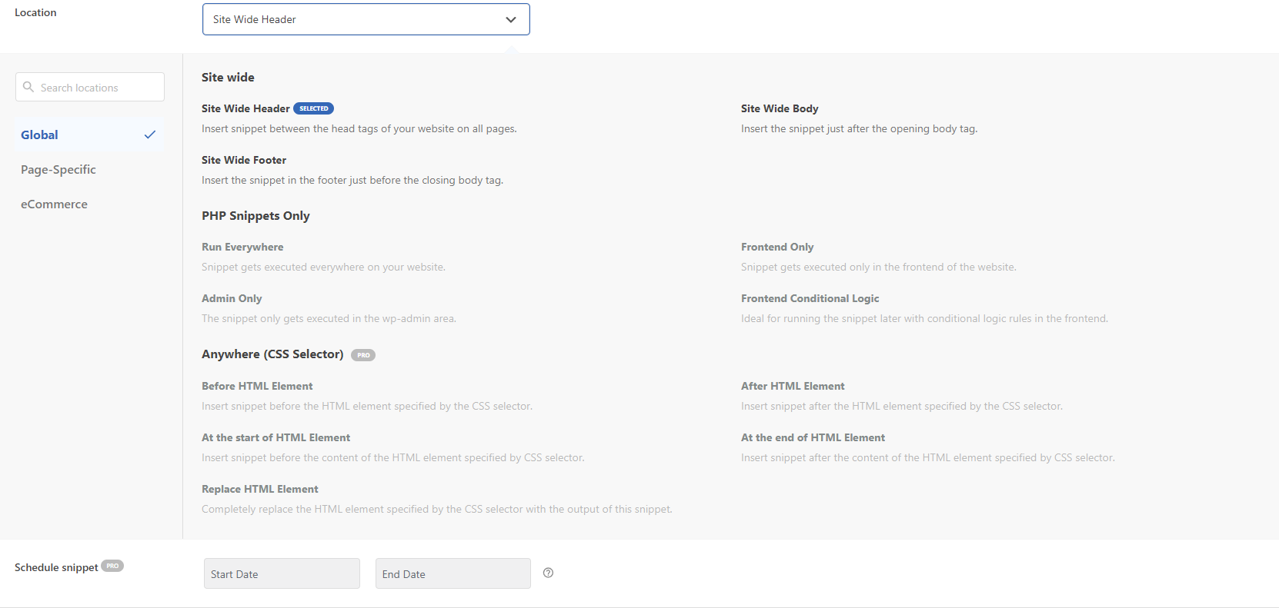

# Global Header & Footer:

The Global Header & Footer Scripts feature in WordPress serves as a convenient centralized hub for incorporating crucial code elements across your entire website. By enabling this feature, you streamline the process of implementing vital snippets or tags without the need for tedious manual insertion on each individual page. This functionality proves particularly advantageous for tasks such as seamlessly integrating tracking codes to monitor site analytics, effortlessly linking with diverse advertising platforms, and enhancing your site's search engine optimization efforts. In essence, it offers a time-saving solution that ensures consistency and efficiency in managing key website functionalities.

1. To add Global Header and Footer, Go to Header and Footer Section of the Plugin.
2. Now, you’ll see 3 sections as Header, Body and Footer. These will hold some Global scripts that can be added to site on every page.
3. Following is an example for the scripts that can be added.

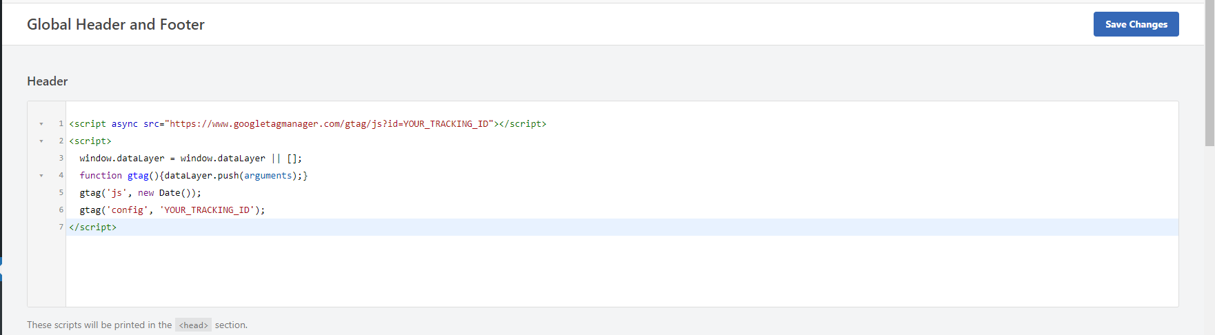

# Safe Error Handling:

The "Safe Error Handling" feature in WordPress is like a safety net for a website's code. When adding custom snippets (small pieces of code) to a WordPress site, there's always a chance that they might cause errors or break the site unintentionally.

This feature acts like a guard, watching over the code. If there's an error, instead of letting it crash the website, the feature steps in and handles it safely. It prevents the error from causing any serious harm to the site.

Think of it like having a friend who catches someone if they trip and fall. They help them stay on their feet instead of letting them hit the ground hard.

With Safe Error Handling, developers can experiment with new code without worrying too much about breaking the WordPress site. It adds a layer of protection, giving peace of mind while tinkering with the website's functionality.

Here is an Example of how WPCode Plugin indicates the line where the error is occurred.  
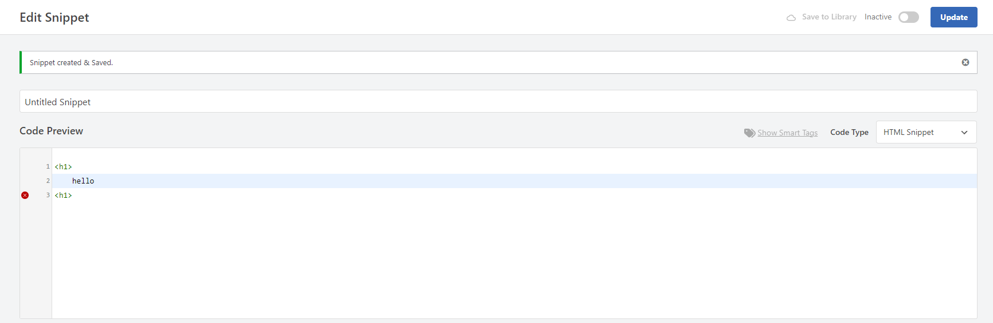

# WordPress Code Generators:

* Admin Bar Menu:

This snippet will likely add a new custom menu to the WordPress admin bar, allowing to link to external URLs, internal pages, or even display custom content within the bar.

* Add Contact Methods:

This snippet will probably add new fields to the user profile edit page, allowing users to specify additional contact information beyond the default ones provided by WordPress.

* Generate Hooks:

This is a more complex snippet generator. It allows to choose an action or filter hook from a list and then generates a code snippet specifically tailored to that hook, enabling to execute custom code at specific points within WordPress.

* Generate Navigation Menu:

This snippet will likely create a new custom navigation menu that can assign to different areas of r website, such as the header or footer.

* Generate Post Status:

This snippet will probably create a new custom status for posts, allowing to categorize them beyond the standard published, draft, etc. options.

* Generate Post Type:

This snippet will likely create a new type of content like "Products" or "Events" with its own set of fields and functionalities separate from posts and pages.

* Register Scripts:

This snippet will likely register a JavaScript file using the wp_register_script function, enabling to load it on website.

* Register Stylesheets:

This snippet will likely register a CSS stylesheet using the wp_register_style function, allowing to load it on website and apply the styles.

* Schedule a Cron Job:

This snippet will likely add a new recurring event to the WordPress cron system, allowing to execute specific code at regular intervals (e.g., hourly, daily, etc.).

* Generate Sidebar:

This snippet will likely create a new sidebar area where can place widgets, offering additional sidebars beyond the default ones provided by theme.

* Generate Taxonomy:

This snippet will likely create a new custom taxonomy for posts, allowing to categorize them further using terms like "Tags" or "Categories" but specifically tailored to content type.

* Generate WP Query:

This snippet will likely create a customized "WP_Query" object, which allows to retrieve specific posts based on various criteria like post type, category, author, etc.

* Generate Widget:

This snippet will likely create a new custom widget that can add to sidebars and customize with specific functionalities.

1. To add the generated code just go to Generator section of the WPCode Plugin. The page will look like this:

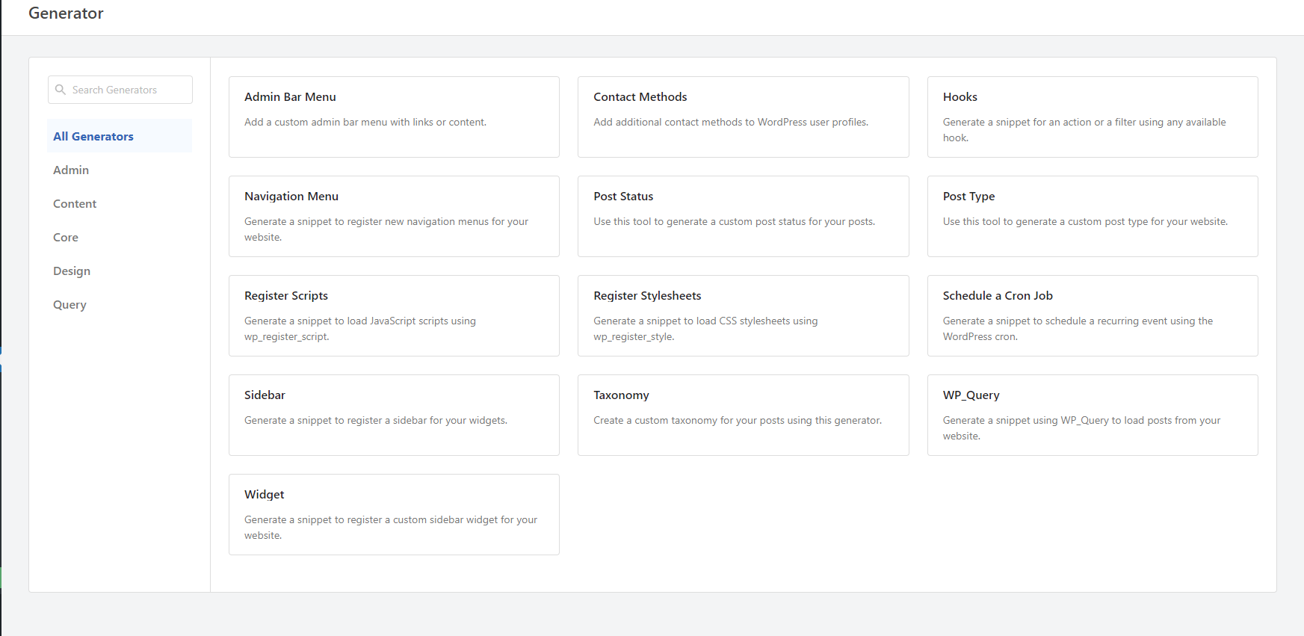

1. There are some limited Generators.
2. For example, we will pick the Sidebar Generator. So, click on Generate button by hovering on the Generator.
3. Now the Plugin will insert the predefined php code for generating a Sidebar.  
   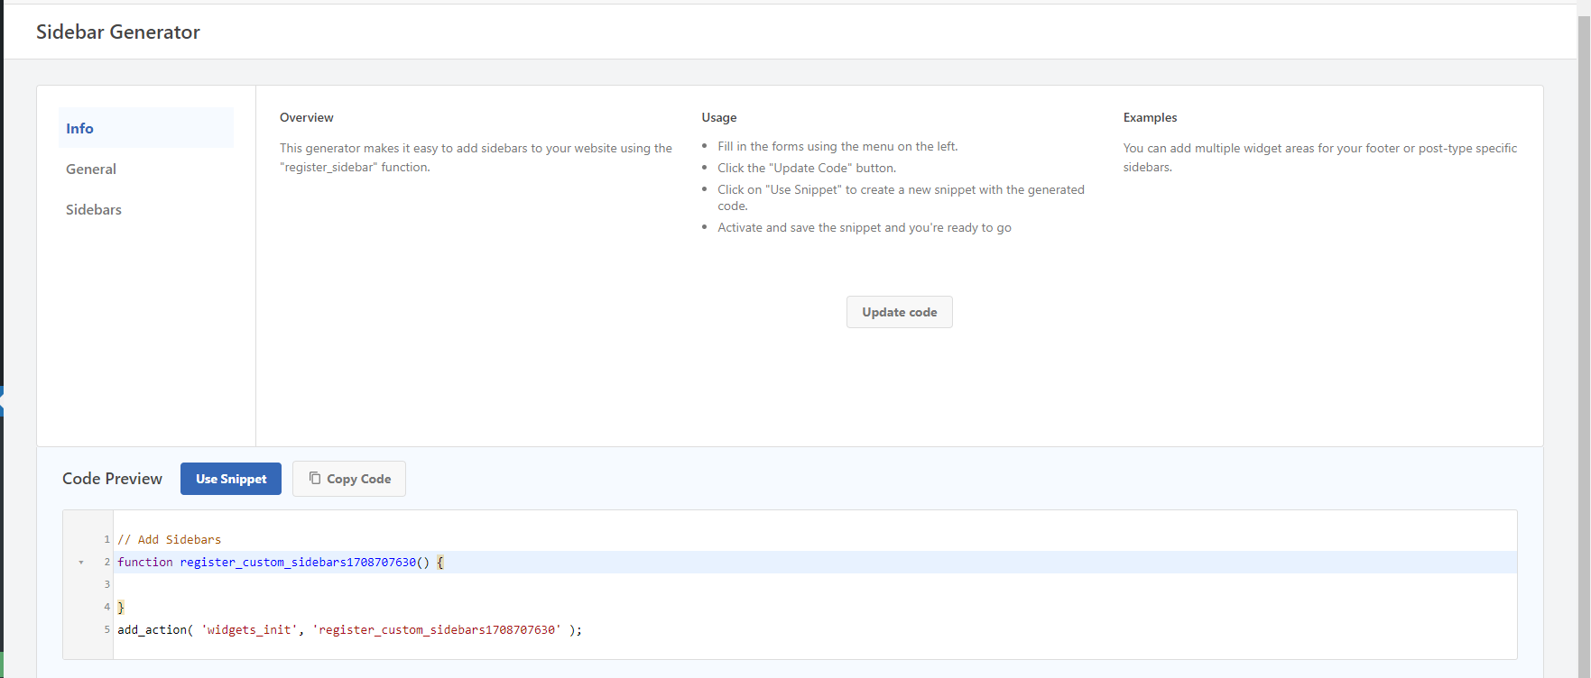

Now to have the generated sidebar on our site, we just have to click the Use Snippet button. And it allows to further edit the code and allows to set as active or inactive as per out need.

# Ecommerce Conversion Pixels:

# Dynamic Content Elements:

Users can reuse content across their site with custom shortcodes in an easy-to-use interface, making content updates simple. WPCode allows you to reuse content across your WordPress site without manually adding it to each page or post. It generates a shortcode or token for the selected code snippets representing that specific dynamic content element. Users can then insert this shortcode or token into their WordPress posts, pages, or custom templates wherever they want the dynamic content to appear.

To add dynamic content element to the site,

You have to create a code snippet in preferred language and requirements. Follow the steps provided in previous sections.

1. Let’s say you have created a code snippet as follows:

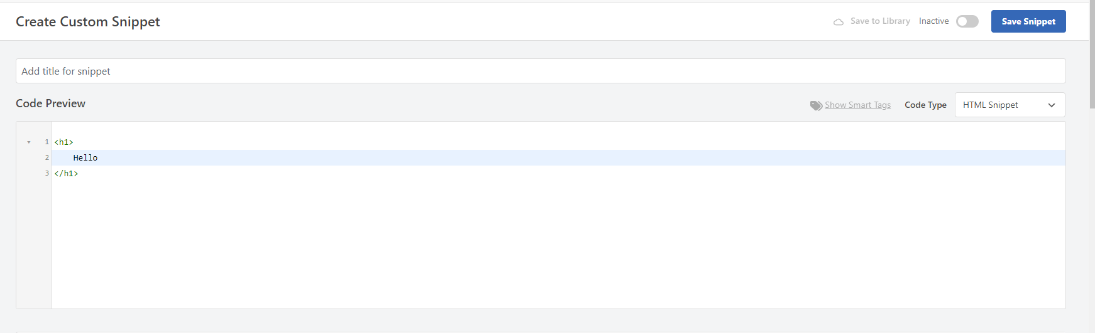

1. Now to create a dynamic content elements scroll a bit. You will see a section as, Insertion as follows:

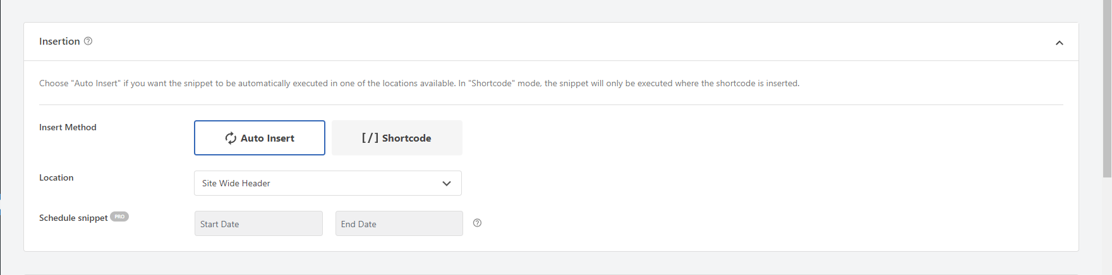

1. Here you can see the Shotcode button which will give us a short code for the created snippet as follows:

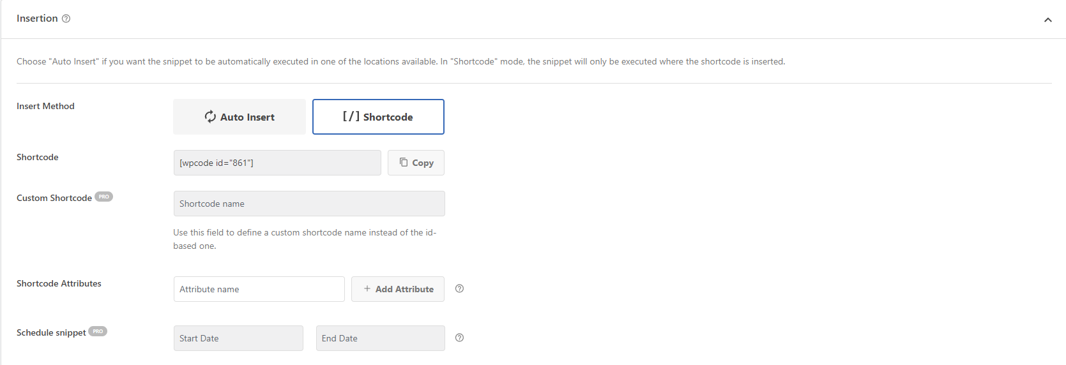

1. There are many more properties to add to the snippet.

# Reduce Number of Plugins:

The WPCode plugin for WordPress aims to make website simpler by combining functions that are usually handled by different plugins into just one set of code.

* Less plugin overload: Ditch all those single-purpose plugins and replace them with focused code snippets. Fewer plugins mean less clutter, easier management, and a happier website.
* Speed boost: Every plugin adds weight to site, slowing things down. With fewer plugins website gets lighter and loads faster, keeping visitors happy and engaged.

Security shield: Fewer plugins = fewer potential security holes. It's like adding extra locks to digital fortress, making it harder for bad guys to get in.

1. To achieve reduced Number of Plugins, we can just add the code with same language to a single file. Just as follows:
2. Let’s suppose we are to add the CSS to the site so we will just combine the CSS code for Header and also the footer so that we don’t need to add separate CSS snippets for different parts.

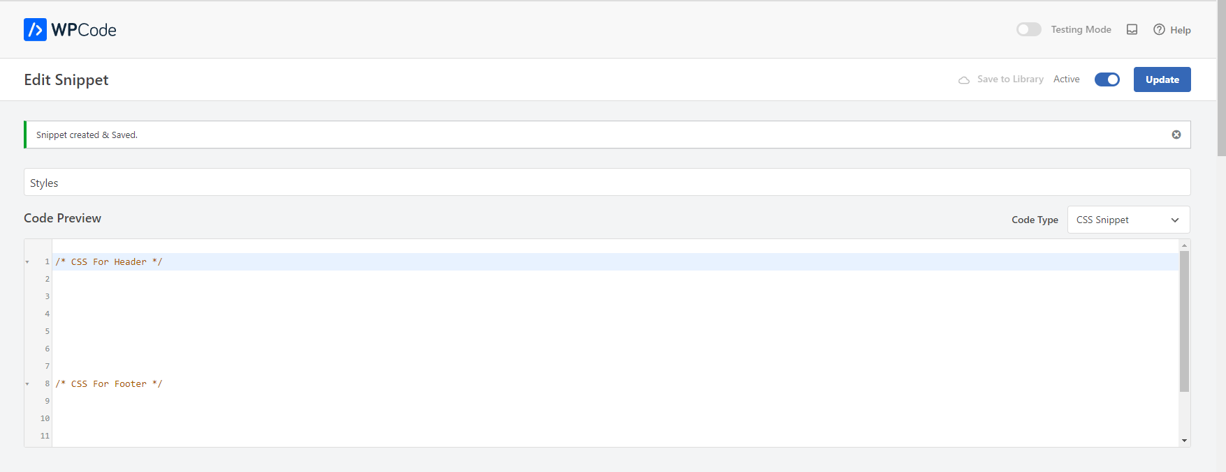

# Save Snippets in Cloud:

WPCode plugin is a powerful tool for managing custom code across multiple WordPress websites.

Allows to store snippets in a private cloud library accessible from any website manage with WPCode.

Saves not just the code, but also details like conditional logic, auto-insert locations, and other settings.

Enables easy reuse of snippets without manual copying and pasting, saving time and reducing errors.

# Easy Code Management:

The WPCode Snippets plugin aims to streamline experience with custom code on WordPress site. It makes it simple to manage and organize code snippets. It allows to store and categorize snippets of code for website without needing to deal with complex coding structures. It provides a user-friendly interface. It allows to categories files and code snippets using tags making it easier to find the required snippets faster.

You can set any Code Snippet as active or inactive with just one click.

For that,

1. You have to go to the dashboard.
2. Then you’ll see a section on left panel of dashboard as Code Snippets.
3. It redirects you to all the snippets that you added to this site.
4. There will be a toggle button that toggles for active and inactive snippets.

